Big Project

Tasks needed to performed to create the project.

- Create a Dockerfile.

- Docker file should to be placed on git.

- Create job in Jenkins, integrate the job with git using webhook.

- Run the job manually first from Jenkins and check if image is created and downloaded.

- Check whether downloaded image is pushed in Docker hub.

- Check if the image is downloaded from Docker Hub and creates container from it.

- Now webhook will come in picture, any changes in the source code on the GitHub repository, then Jenkins job should run and download the image from Docker Hub.

- Check If container is created then delete the container and create a new one with the changes.

Before performing the above tasks, we need to create some pre-requisites.

- We need to have an account in GitHub with a public repository created in it. This required so that we can put our DockerFile.

- An EC2 instance which has jenkins and docker installed on it.

- Docker Plugins should be installed & configured on Jenkins.

- Add jenkins user to docker group to execute docker commands from jenkins.

- A Docker Hub account with a public repository created in it. This is required for pushing and pulling images from Docker Hub.

Pre-requisites are performed as below:

- We need to have an account in GitHub with a public repository created in it. This required so that we can put our Dockerfile.

In my case, I have a GitHub Account and public repository created in it with the name “Project”. Below is the link for the repository.

GitHub Account

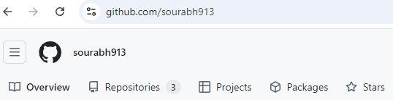

Project Repository

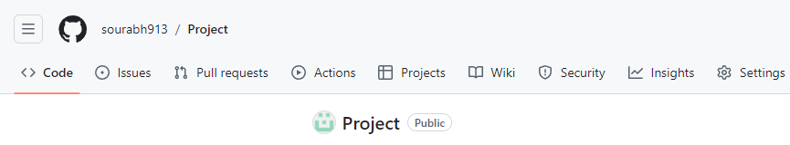

GitHub Repository link

https://github.com/sourabh913/Project.git

- An EC2 instance which has jenkins and docker installed on it.

Docker is installed through predefined commands specified in user data.

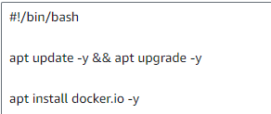

EC2 Instance

Docker Installed

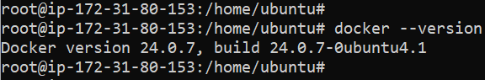

Jenkins is installed using the below shell script on the same EC2 instance. We will need to make necessary changes in the script as per our need, like Jenkins URL, username, password, full name and email id

http://184.73.109.231:8080 (Jenkins URL)
user – test
password – abc123
Full Name - Sourabh
email id – a@a.com

Jenkins Installed successfully.

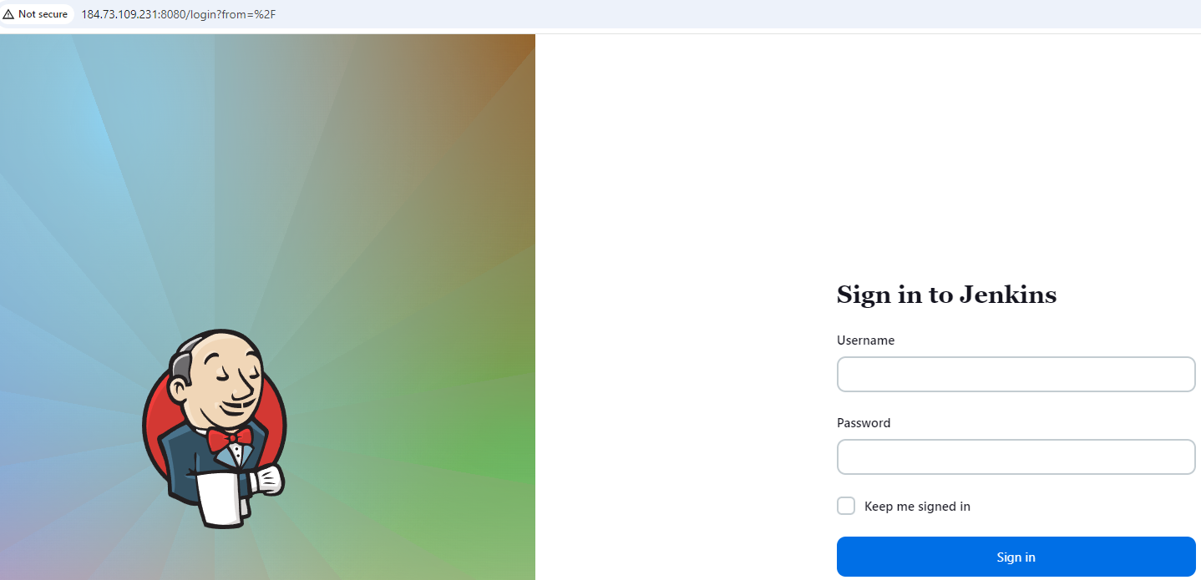

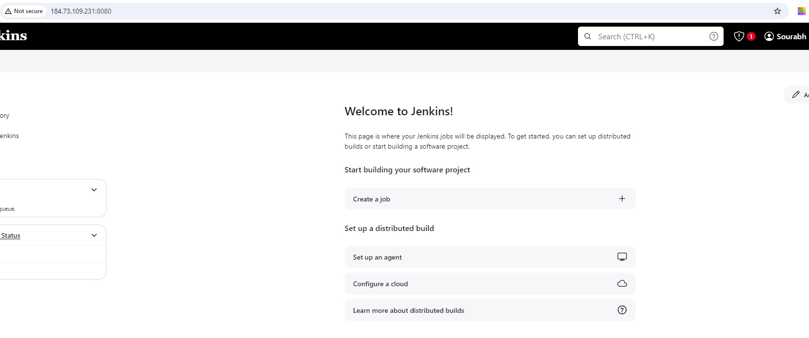

- Below mentioned docker plugins should be installed.

- Docker

- Docker-build-step

- CloudBees Docker Build and Publish

- Docker pipeline

Above mentioned plugins have been installed.

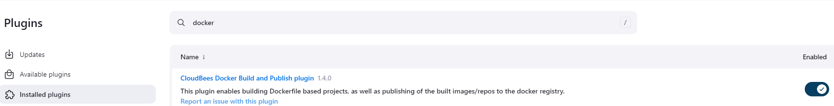
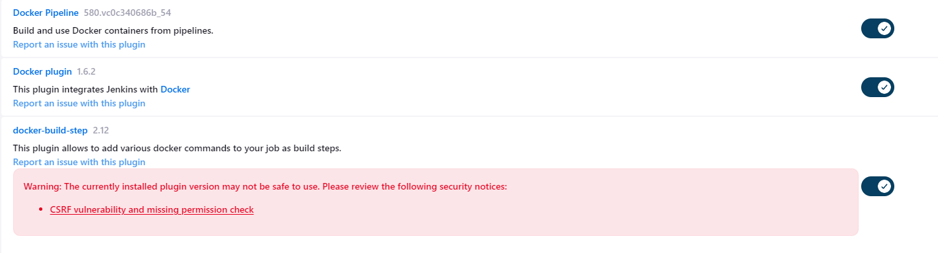
We need to configure Jenkins to use the existing docker installed on EC2 instance. Steps are below:

Go to Manage Jenkins >Tools

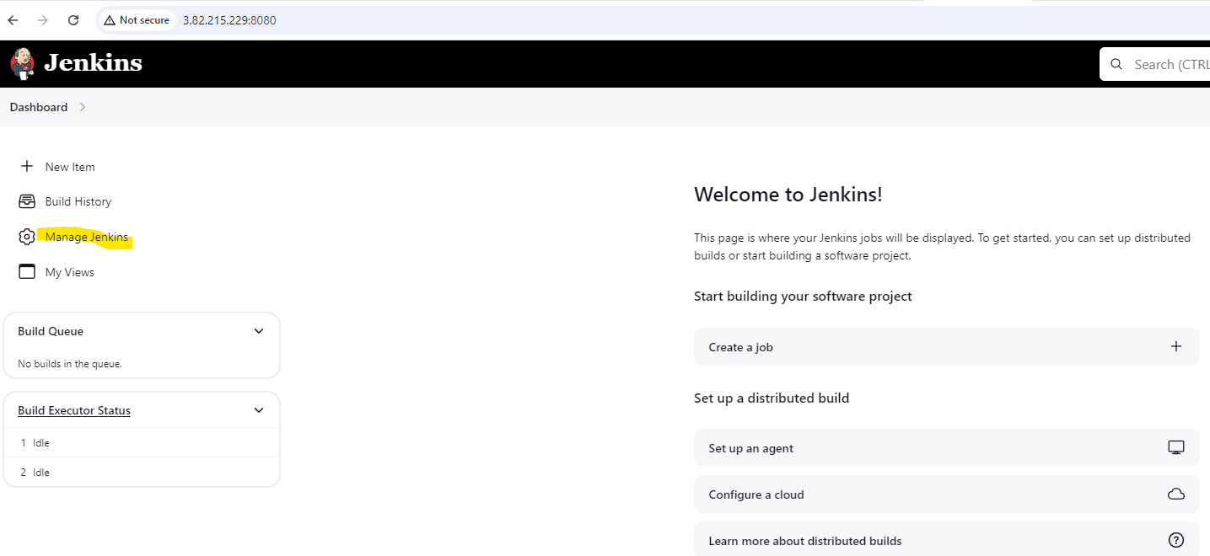
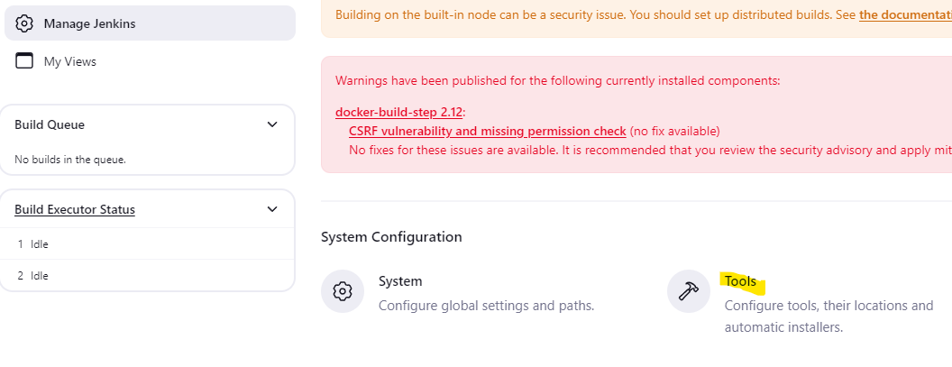

Under Tools > Scroll down to the bottom > Add Docker

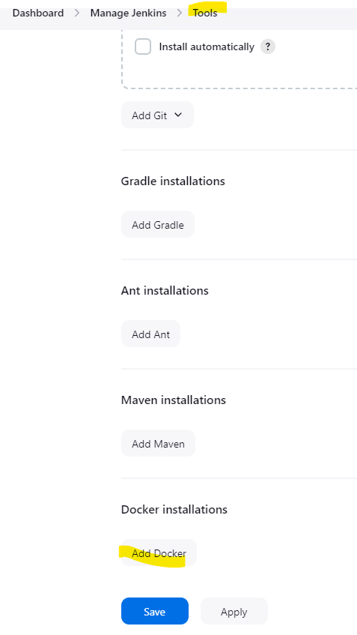

Under Docker, type a name, in our case, we gave “Docker” only, we can leave Installation root as blank and it will take the default installation path. Click Apply and Save.

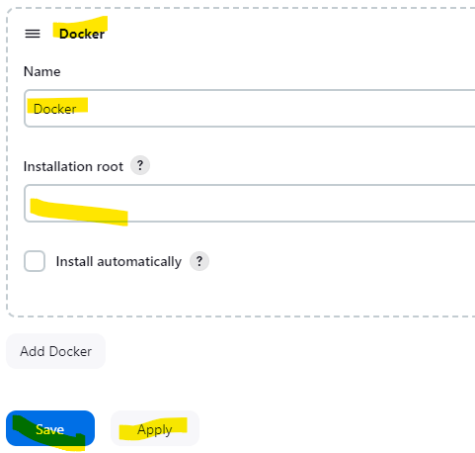

- Add jenkins user to docker group to execute docker commands from jenkins.

This can be done by running the below command on EC2 instance.

usermod -a -G docker jenkins

User addition and Plugins installation requires jenkins restart to take affect by using the below commands.

systemctl restart jenkins

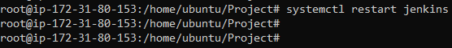

- A Docker Hub account with a public repository created in it. This is required for pushing and pulling images from Docker Hub.

In my case, I have a Docker Hub Account and public repository created in it with the name “sourabh1018”. Below is the link for the repository.

Docker Hub Account

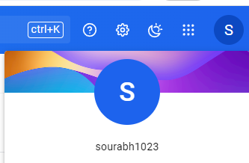

mynginx repository

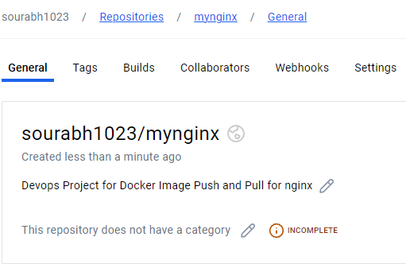

Pre-requisites have been completed.

Tasks performed are as below:

- Create a docker file.

In our case we are creating a Nginx dockerfile.

To create a dockerfile for nginx, we need to first create index.html file.

vi index.html

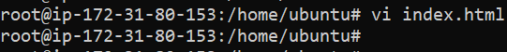

Contents of index.html file:

<!DOCTYPE html>
<html>
<body>
<h1>Welcome to Nginx Web Server</h1>
<p>This server is running through Docker container</p>
</body>
</html>

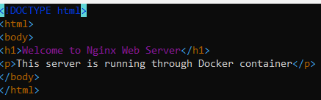

Now we will create the Nginx Dockerfile

vi Dockerfile

Contents of Dockerfile:

FROM nginx
LABEL maintainer="Sourabh Singh"
COPY index.html /usr/share/nginx/html

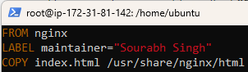

- Docker file to be placed on git.

To put the Dockerfile and index.html on GitHub, we will need to first clone the repository on our EC2 instance.

Cloning the Project Repository on the EC2 instance.
git clone https://github.com/sourabh913/Project.git

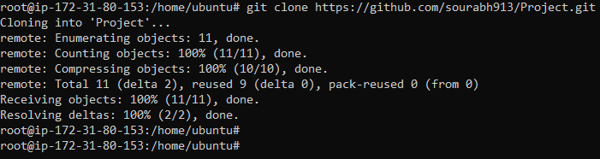

Verify the Repository is cloned
cd Project/

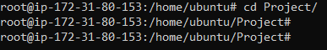

Copying the index.html and Dockerfile on Project Repository.

cp index.html Dockerfile Project/

Verify the contents have been copied on the repository.

ls -ltr

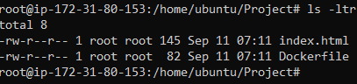

Now we have to push the changes to our repository by following the below steps.

Run the below command on Project repository to check the current git status

git status (command to check git status)

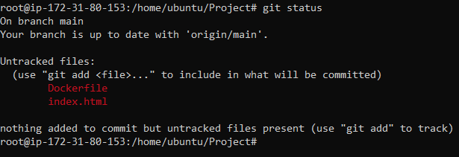

Above screenshot shows that there are untracked files on git, so to add them we will run the below command.

git add . (this command will include all the files in the current folder for tracking)

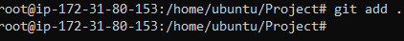

Again, we will check git status to see if the files have been added for tracking or not.

git status (command to check git status)

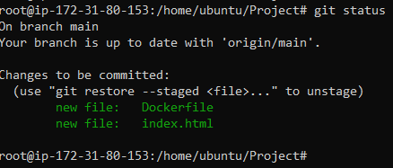

We can see in the above screenshot that the files are added for tracking and they need to be committed to apply the changes by using the below command.

Before running commit, we need to set the global username and user email for GitHub account on our EC2 instance as it takes user credentials of EC2 locally not the GitHub account details by using the below commands.

Setting Global user name

git config --global user.name "sourabh913” (This is for my case and it may differ for others)

Setting Global user email

git config --global user.email "ssourabh139@gmail.com"

git commit -m “Nginx Docker” (Command is used to commit the files that have been added for tracking with -m for giving any message before committing)

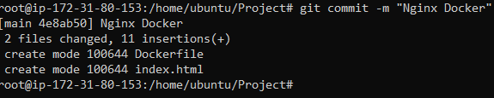

Now we will push the changes in git repository.

Before pushing the changes, we need to run the below command to check if there are any files already in the git repo which are not there in the cloned directory. If there is nothing then we are good to push our changes.

git pull (Command to pull any changes that are already there on the git repo)

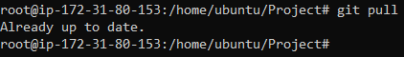

To push the files on our git repo, we need to generate PAT (personal access tokens to use as password)

Steps to generate personal access tokens are as follows:

On the GitHub, dashboard, Click on profile picture.
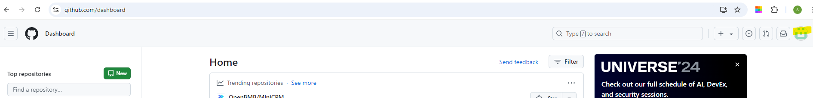

Click on Settings

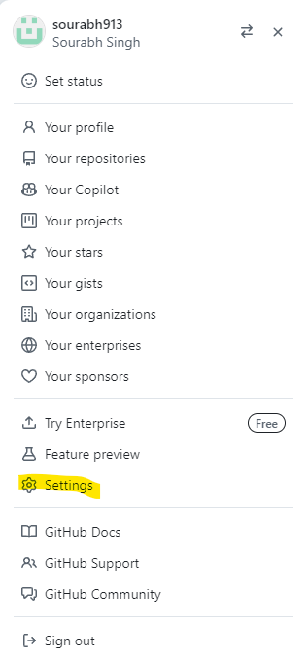

Scroll down to the bottom and click on Developer settings.
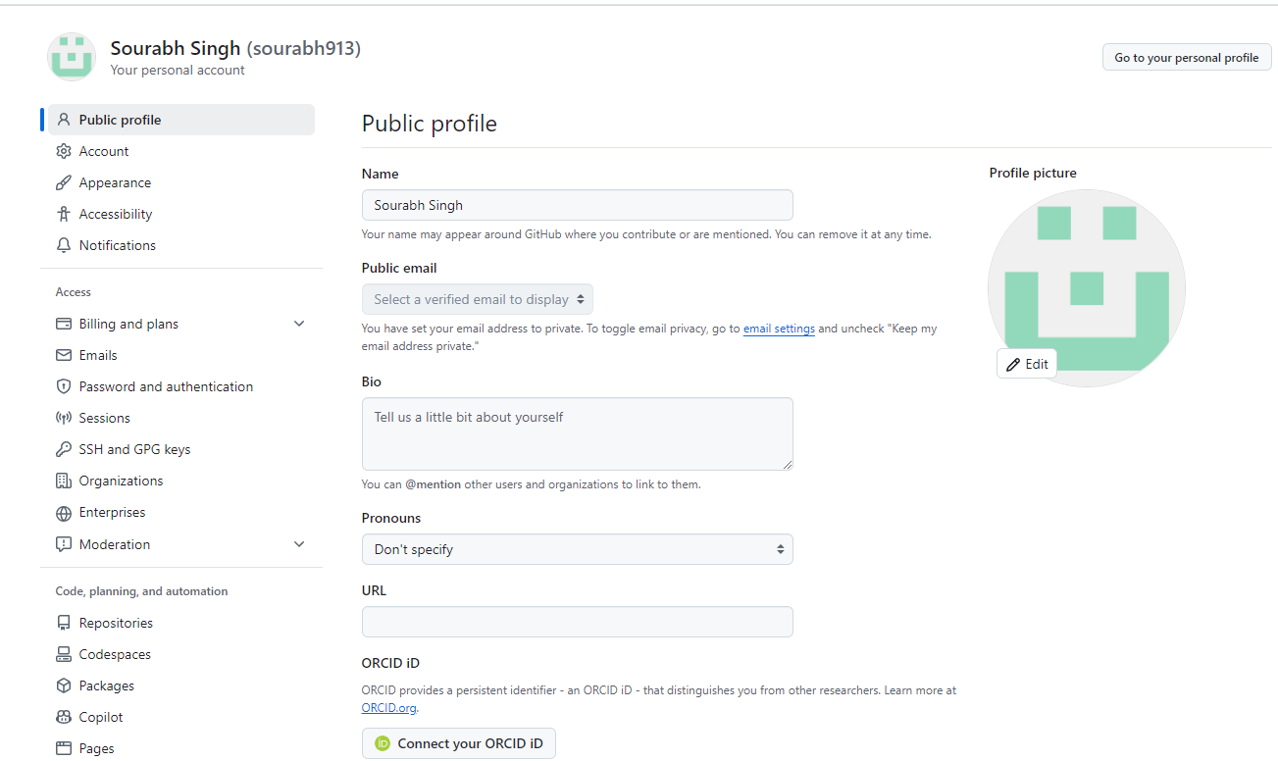

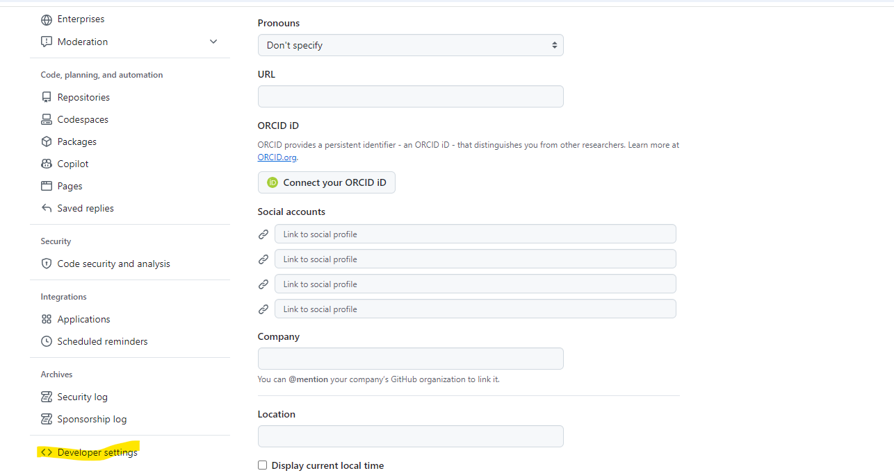

Now Click on Personal Access Tokens > Token Classic > Click Generate new token

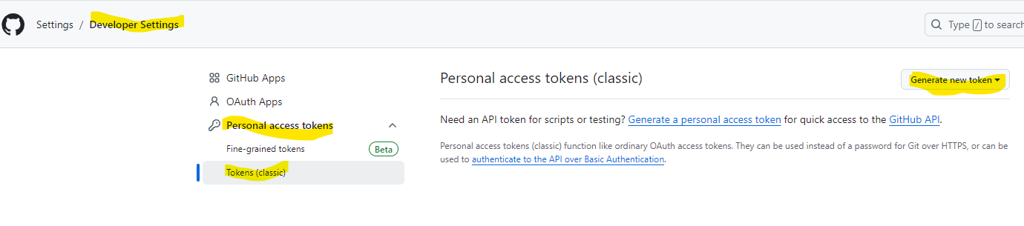
Under Generate new token > Drop down to Generate new token (classic)

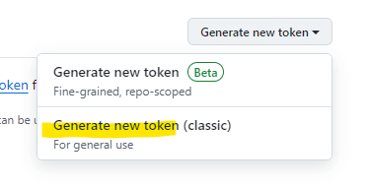
Enter your GitHub Credentials

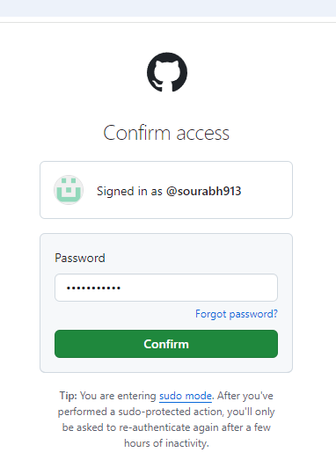

Now you give any description, we have selected write: packages, which will server our purpose for push and pull in Git

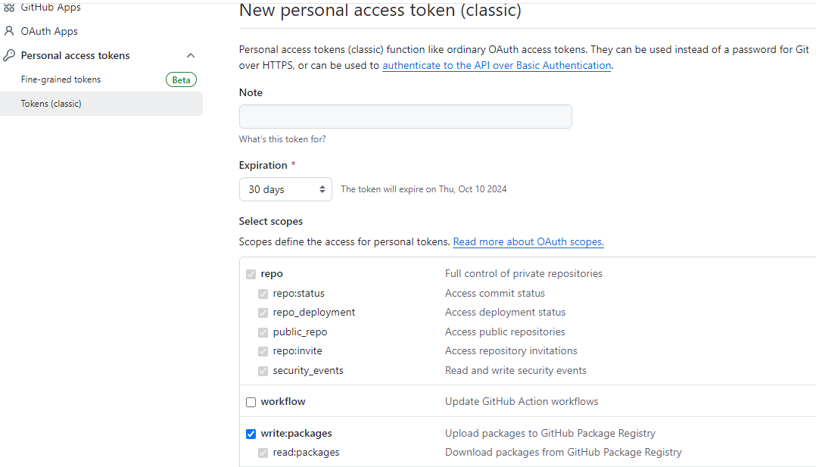

Once the above is done, we will click Generate token

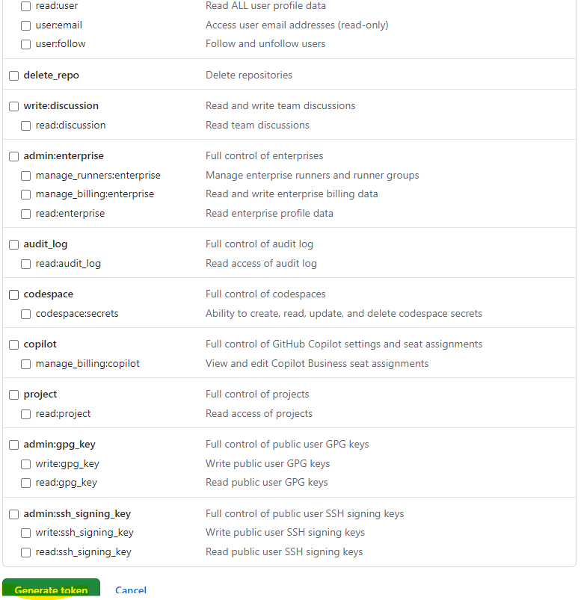

Now we will make a note of this token and use for push out any commits.

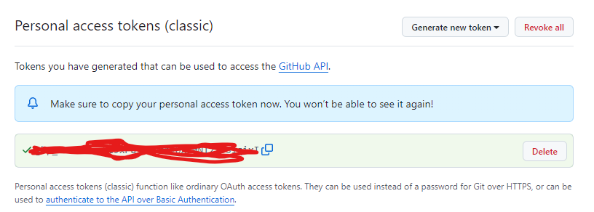

Now we will push our changes in git using our GitHub credentials

git push origin main (Command to push the changes to GitHub Repo)

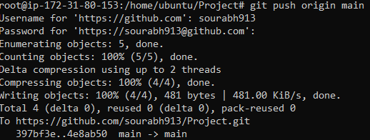

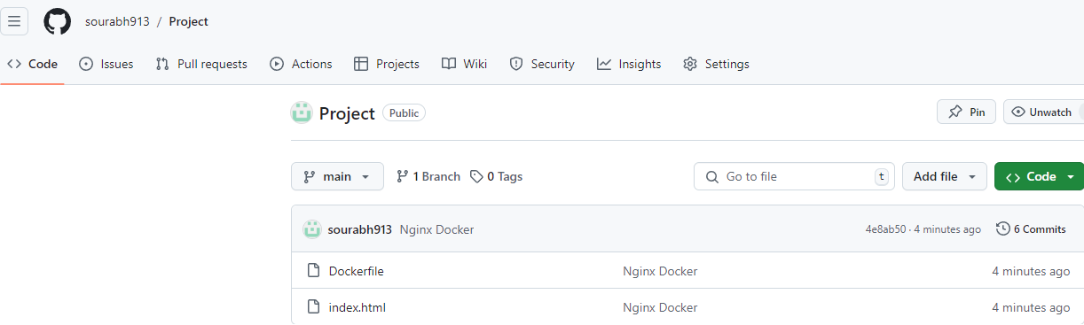

- Create job in Jenkins, integrate the job with git

Create a freestyle Job named “dockerbuild”

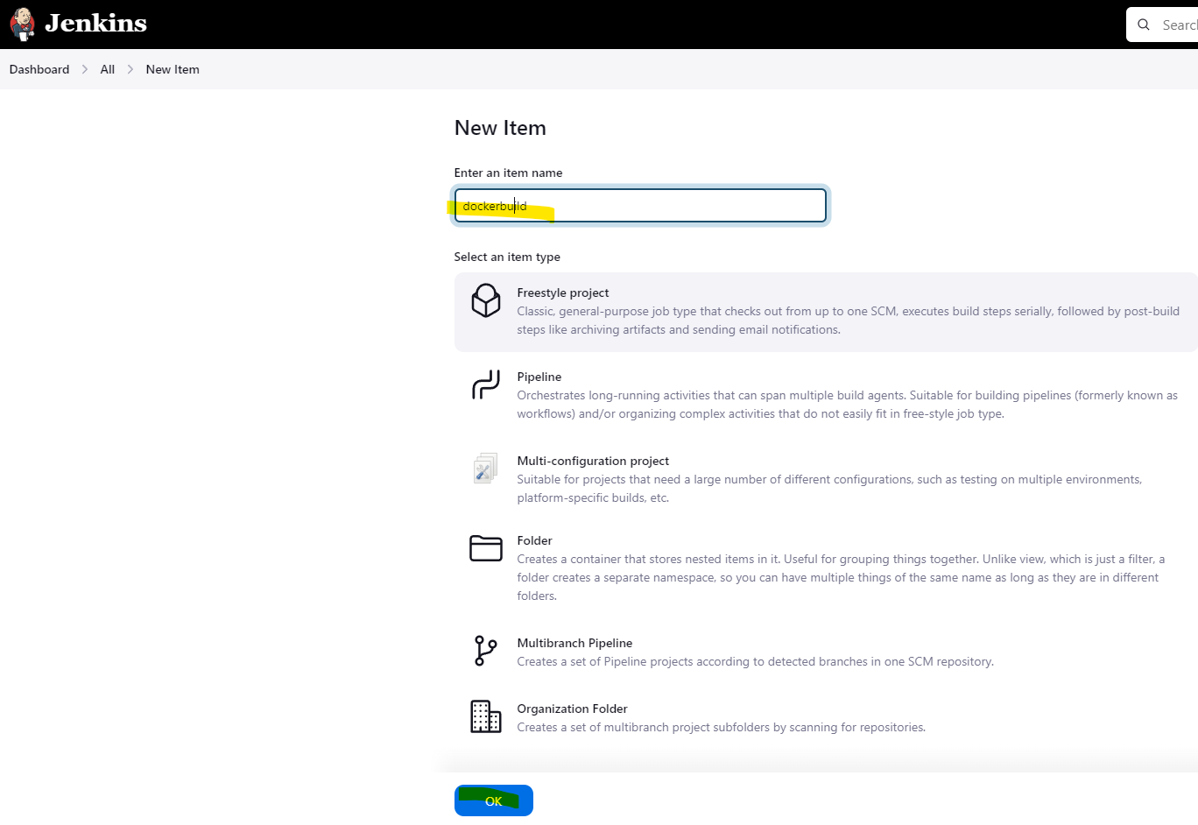

Give the General Description

Under Source Code Management > Select Git

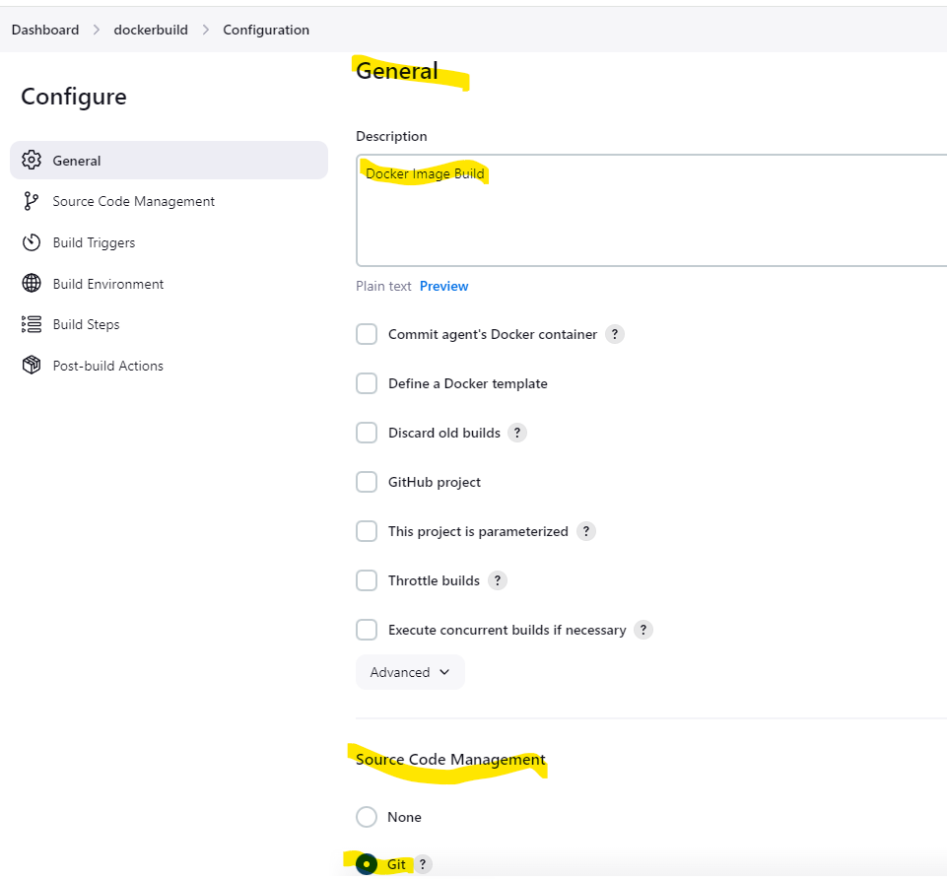
Under Repository URL > Type the URL
https://github.com/sourabh913/Project.git

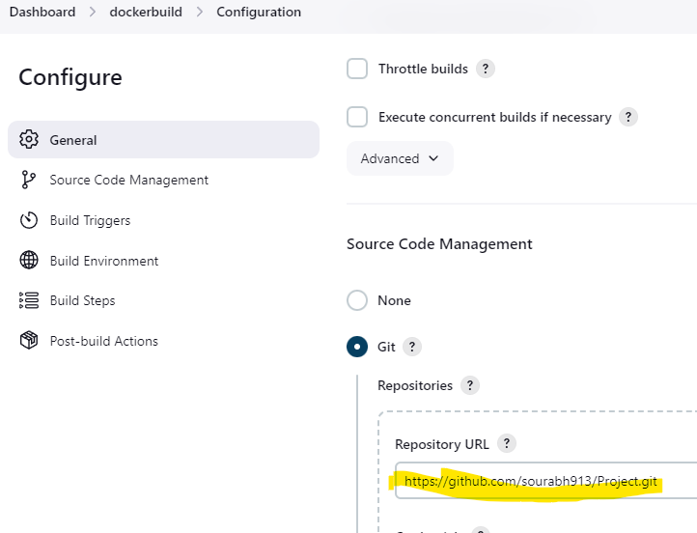
Under Branch we will write */main since our GitHub repo has main branch

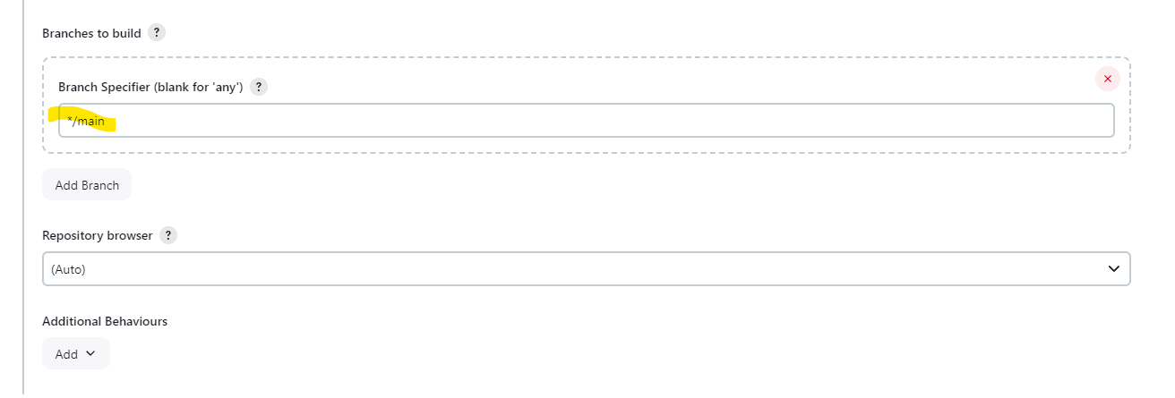

Verifying the same on our GitHub Repo.

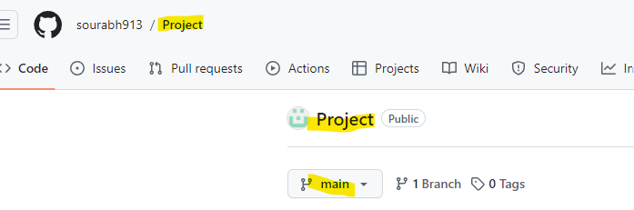

Now we will select the option of GitHub hook trigger for GITScm polling and under Build Environment > Select Delete Workspace before build starts

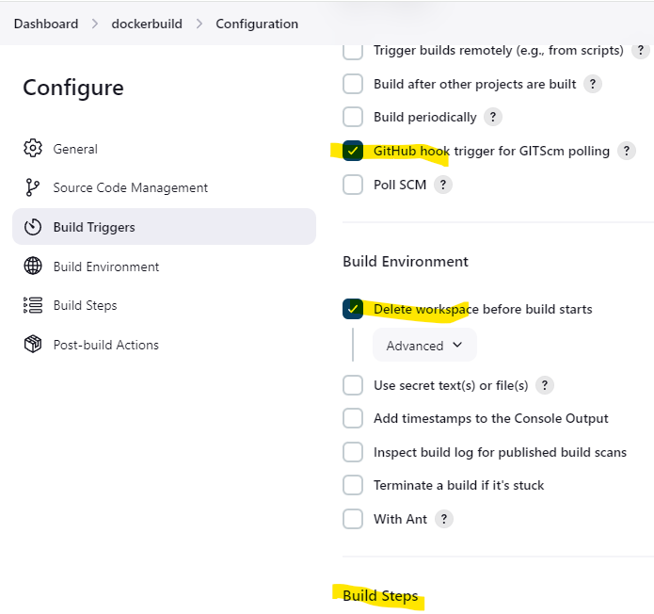
Under Build Steps > Add Build Step and then drop down/up to Docker Build and Push

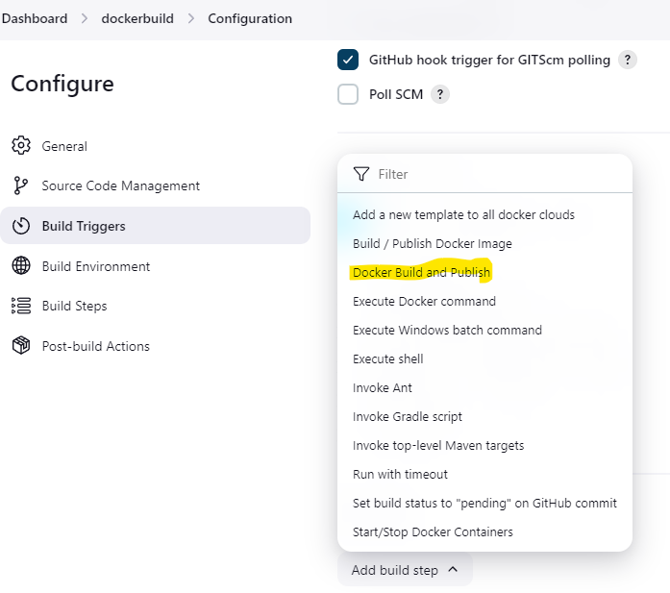
Under Build Steps>Repository name> we will give our repository details created on Docker Hub i.e.
sourabh1023/mynginx

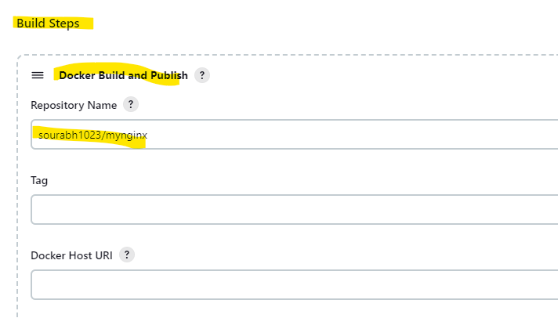
Now we will add the registry credentials i.e. our Docker Hub Credentials. Click Add > Jenkins

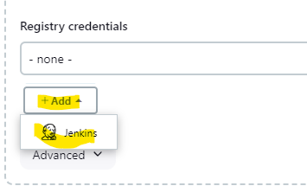

We will give our username as below.
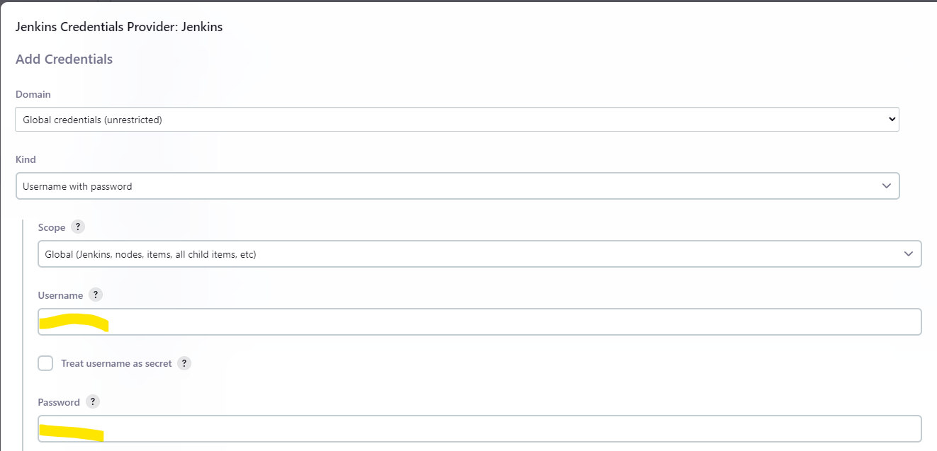

To put password for the Docker hub in Jenkins, we need to generate a personal access token on the Docker hub by using the below steps

On your docker hub, Go to Account Settings

Under Account Settings > Personal access tokens

There will be new access token creation request.

Fill the token details

Under access and permissions select Read & Write

click generate

You will get the below screen with token details. Copy the token as password in the jenkins registry credentials screen

Now again we will click on Add build step and select Execute Shell.

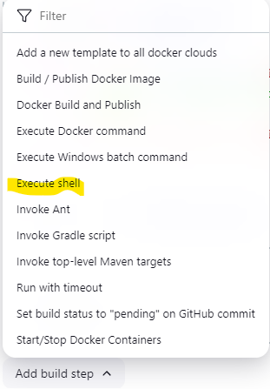

In the shell, we will write the below shell script, which will check if there are any containers matching our given name, if there are any containers running with same name, it will stop and delete the container and create a new one.

container_name="my-nginx-container"

if [ "$(docker ps -q -f name=$container_name)" ]; then
echo "Container $container_name is running. It will be stopped ... "
docker stop $container_name
docker rm $container_name
else
echo "Container $container_name is not running."
if [ "!$(docker container inspect $container_name > /dev/null 2>&1)" ]; then
# cleanup
echo "removing stopped container $(docker rm $container_name)"
fi
fi

docker run --name $container_name -d -p 8081:80 sourabh1023/mynginx

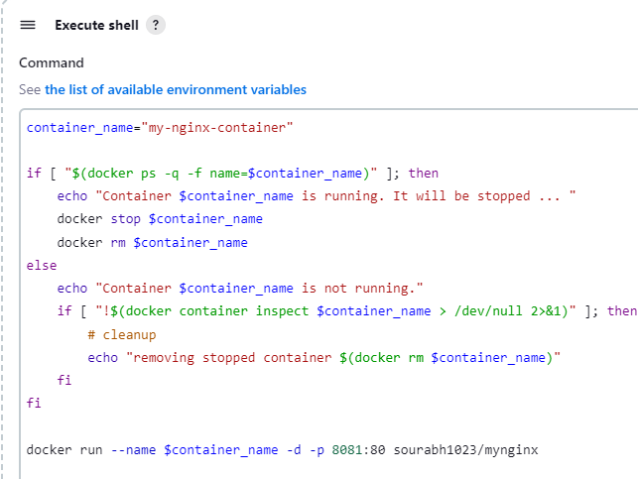
Then Click Apply and Save the Build configuration.

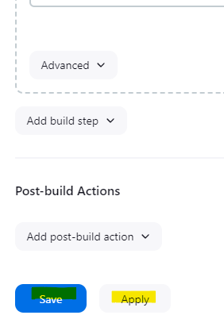

Now we will integrate this project with our GitHub Repo using webhook,

This is used when a job needs to be triggered when there is any change in the GitHub repo.

Steps to followed are below:

While configuring the job, Check the option of GitHub hook trigger for

GITScm polling under Build Triggers and then click Save.

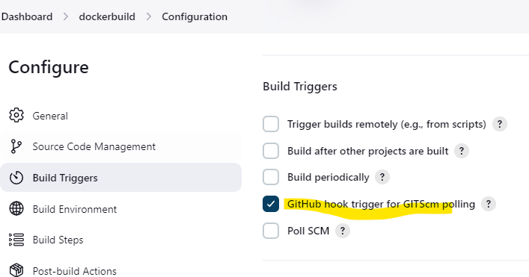

Then on the GitHub side, Go to Settings

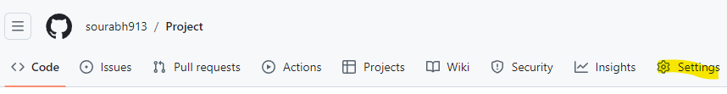

Select Webhook and Click on Add Webhook

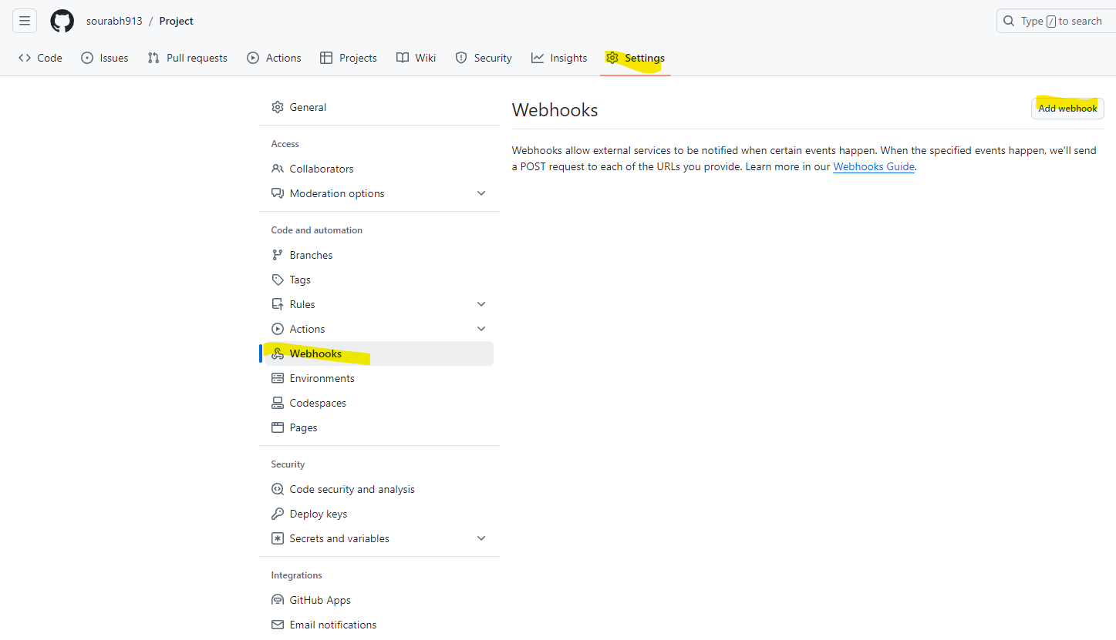
Now we will give our Jenkins URL under Payload URL in the below manner.

http://184.73.109.231:8080/github-webhook/

Rest other settings will remain as it is on the page and will click add webhook.

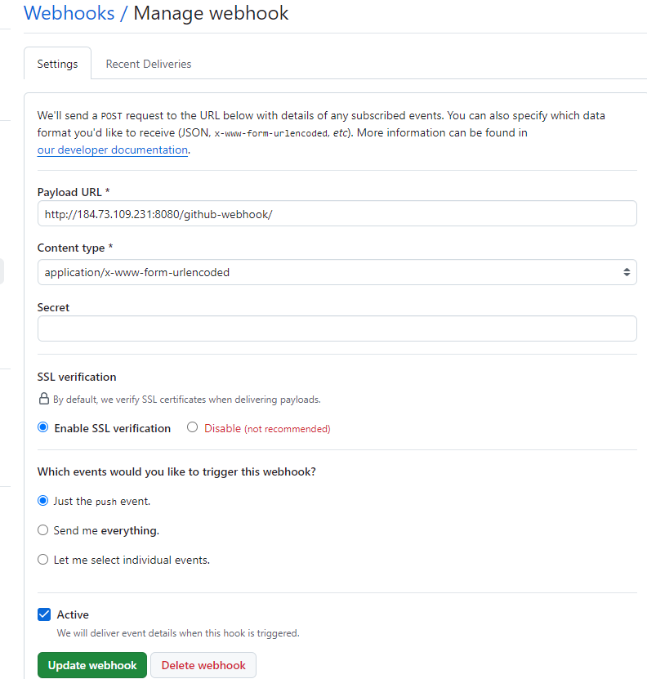

We see that the Webhook is created successfully.

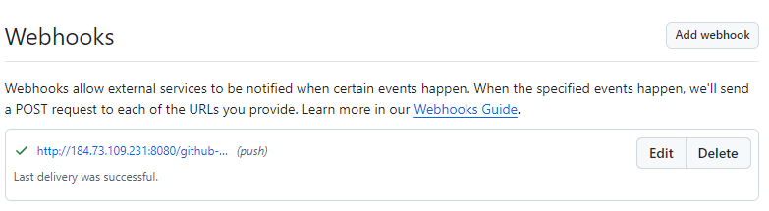

- Run the job manually first from Jenkins and check if image is created and downloaded.

We will run the build for the first time manually to see if gets successful.

Run Build now on the dockerbuild project

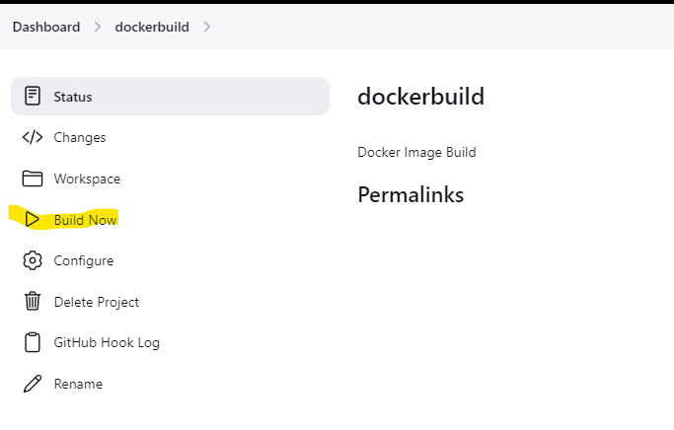

We see the build got successful. In my case I did some R&D, i.e. the Build Number is showing 22.

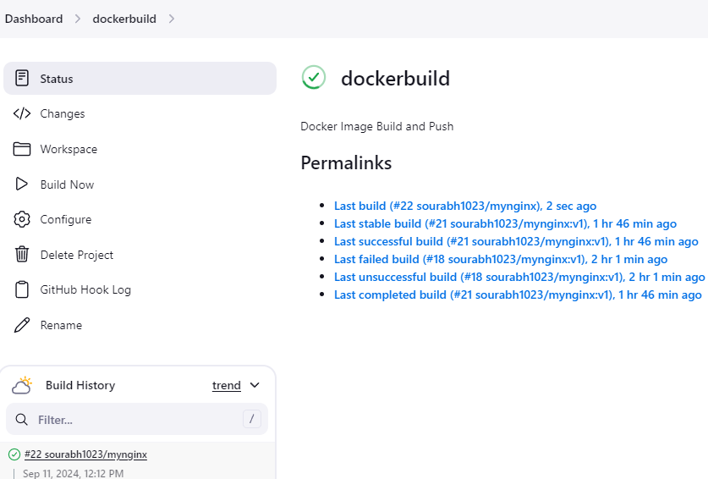

We will see the console output and it shows the details that took place.

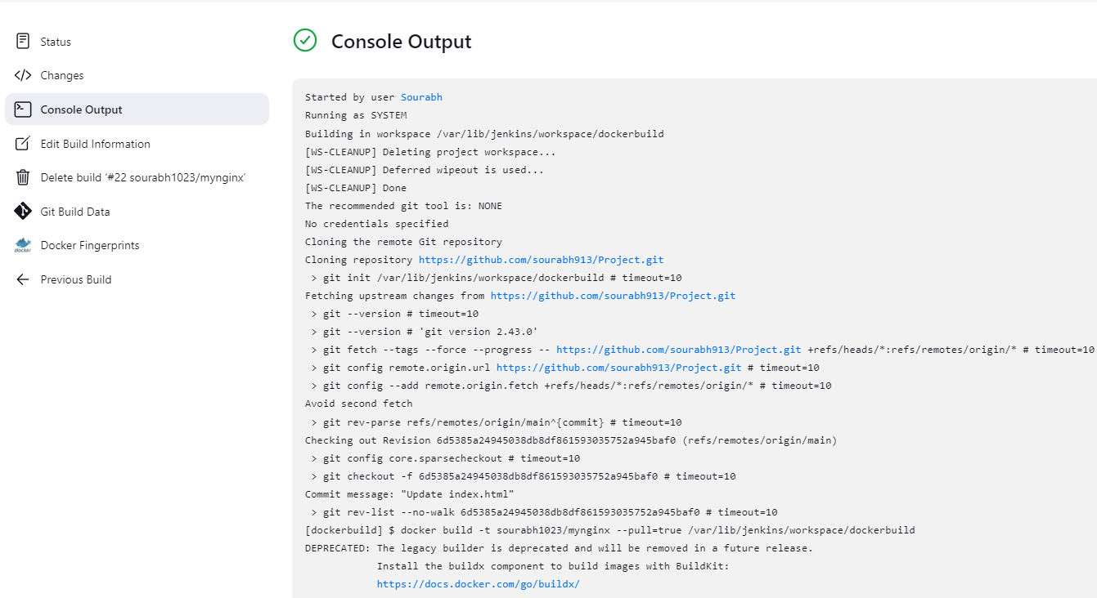
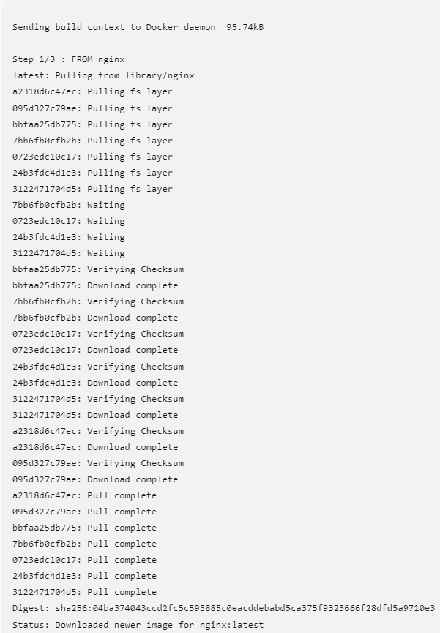
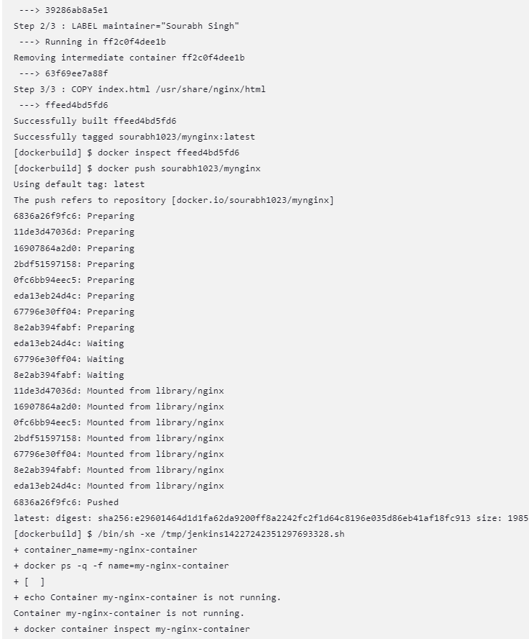
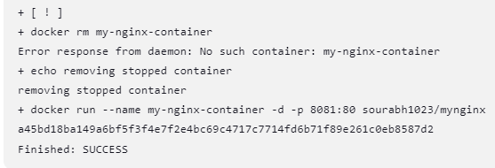

To verify that our image is downloaded on the EC2 instance, we will run the below command.

docker images

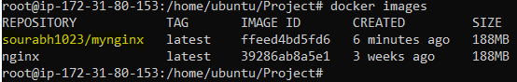

The above screenshot confirms that image is created and downloaded on the EC2 instance.

- Check whether downloaded image is pushed in Docker hub.

Now we will check whether image is pushed on docker Hub.

Below Screenshot confirms that image is pushed on Docker Hub.

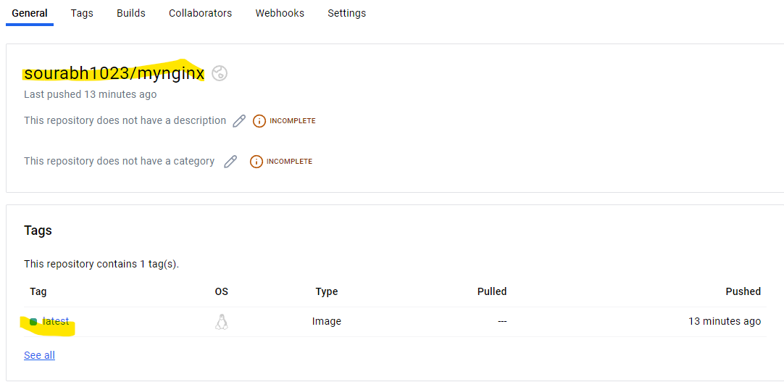

- Check if the image is downloaded from Docker Hub and creates container from it.

Below screenshot confirms that container is created from the downloaded image.

Below is the output of our first Project run for ngnix

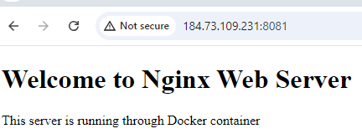

- Now webhook will come in picture, any changes in the source code on the GitHub repository, then Jenkins job should run and download the image from Docker Hub.

In this task, we will edit the index.html file and make the below changes, commit and push those changes on the GitHub to see if the Jenkins job is triggered automatically.

vi index.html

Contents of changed index.html file:

<!DOCTYPE html>
<html>
<body>
<h1>Welcome to Nginx Web Server</h1>
<p>This server is running through Sourabh Singh docker container</p>
</body>
</html>

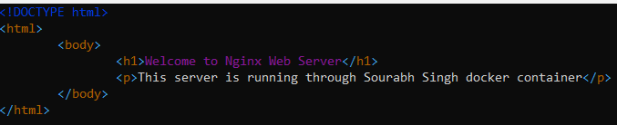

Now we have to push the changes to our repository by following the below steps.

Run the below command on Project repository to check the current git status

git status (command to check git status)

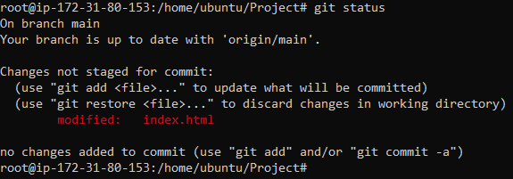

Above screenshot shows that there are untracked files on git, so to add them we will run the below command.

git add . (this command will include all the files in the current folder for tracking)

Again, we will check git status to see if the files have been added for tracking or not.

git status (command to check git status)

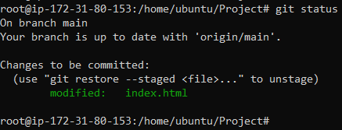

We can see in the above screenshot that the files are added for tracking and they need to be committed to apply the changes by using the below command.

git commit -m “Index File Changes” (Command is used to commit the files that have been added for tracking with -m for giving any message before committing)

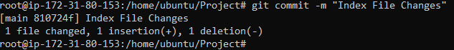

Now we will push the changes in git repository.

Before pushing the changes, we need to run the below command to check if there are any files already in the git repo which are not there in the cloned directory. If there is nothing then we are good to push our changes.

git pull (Command to pull any changes that are already there on the git repo)

git push origin main (Command to push the changes to GitHub Repo)

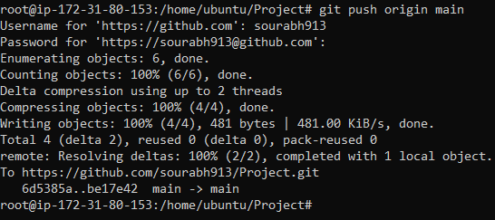

We can see that immediately after pushing the changes, Jenkins Job Ran and it got successful. Build 23 completed successfully.

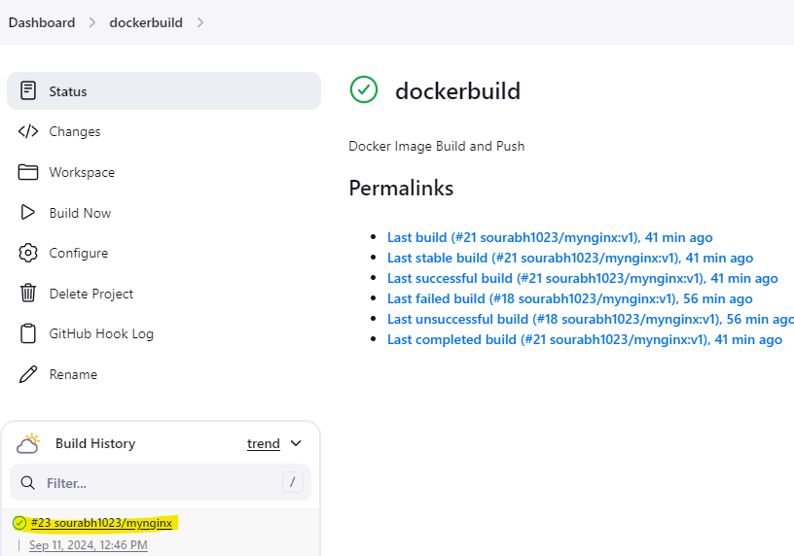

Build details shows that webhook worked as it took the changes in index.html
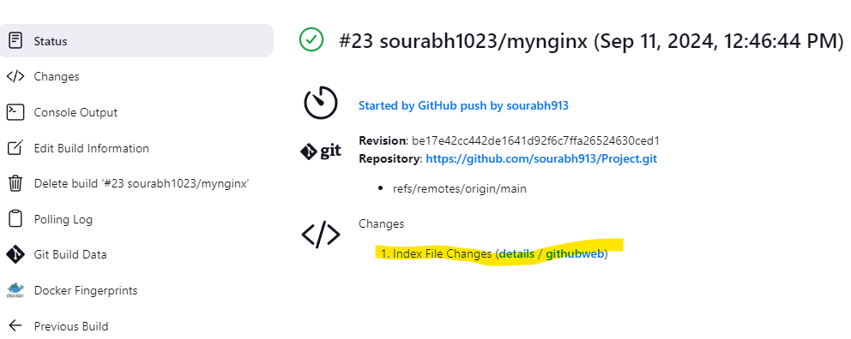

Console Output gives the below output
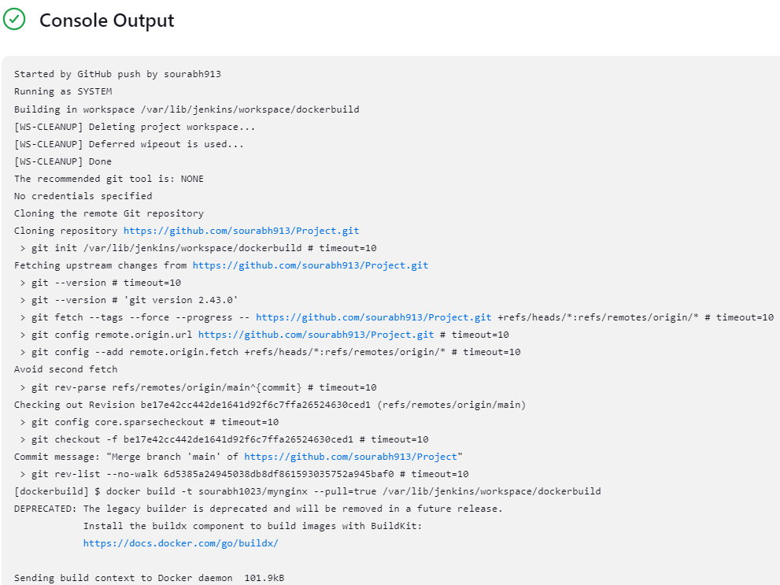
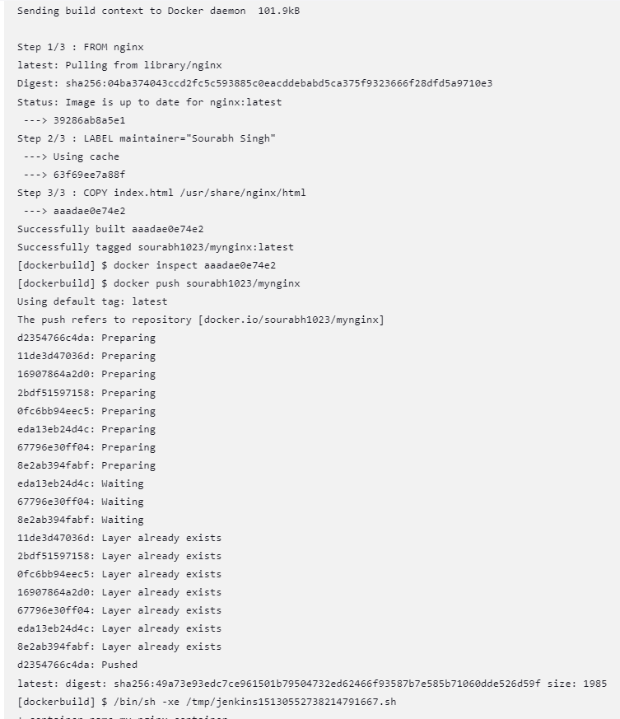
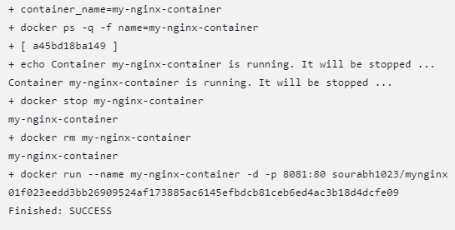

Below is the output of after the index.html changes were done for ngnix

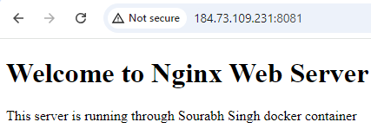

- Check If container is created then delete the container and create a new one with the changes.

Below screenshot of console output shows that the existing container with the same name is delete and new container with same name is created with new container ID.

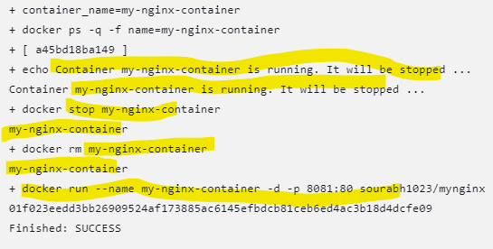

Container running before we made changes to the index.html file.

Container running after we made changes to the index.html file.

All the tasks have been completed successfully.

